

|  |
| --- |
| Version 1.1  **Last saved by:** Ben McGregor  **Last saved on:** 31/03/2015 |

|  |
| --- |
| Iteration 1 Plan |
| 29/09/2014 |
| **Charlotte Hutchinson**  CO600: JustHealth Supervisor: Yang He |

Contents

1.0 Aims: 3

2.0 Requirements: 3

2.1 Functional requirements: 3

2.2 Non-functional requirements: 3

2.3 Domain Requirements: 3

3.0 Design 4

3.1 Login screen design and registration page 4

4.0 Usecase: 5

5.0 Database design: 5

5.1 Assumptions: 5

5.2 Conceptual Data Model 6

5.3 Logical Data Model 6

JustHealth Iteration 1 Plan

# Aims:

* To have a fully functioning database with a web login screen
* The ability for users to be able to register and log in
* The login screen does not allow any erroneous data or attacks
* A 5 times failed login where the user will have to reset their password

# Requirements:

## 2.1 Functional requirements:

* Ability to register an account
* Ability log in to that registered account
* Ability to reset password
* A user will be locked out after 5 failed attempts

## 2.2 Non-functional requirements:

* User Documentation
* Security
  + Encryption of passwords and sensitive user information
  + In-line network security
  + Physical network security
* Robustness
  + Error handling
  + Security (as above)
  + Eliminate the possibility of SQL injection type attacks
* Ease of Use
  + Simple and intuitive design
  + Clear colour scheme

## 2.3 Domain Requirements:

* Security
  + Legal requirements will mean that the sensitive information e.g. password will need to be encrypted.
  + Terms and conditions accepting on registration
  + Tick box to acknowledge that data provided is accurate and that it is the responsibility of the user to keep this information up-to-date and is not the responsibility of JustHealth (registration)

# 3.0 Design

## 3.1 Login screen design and registration page

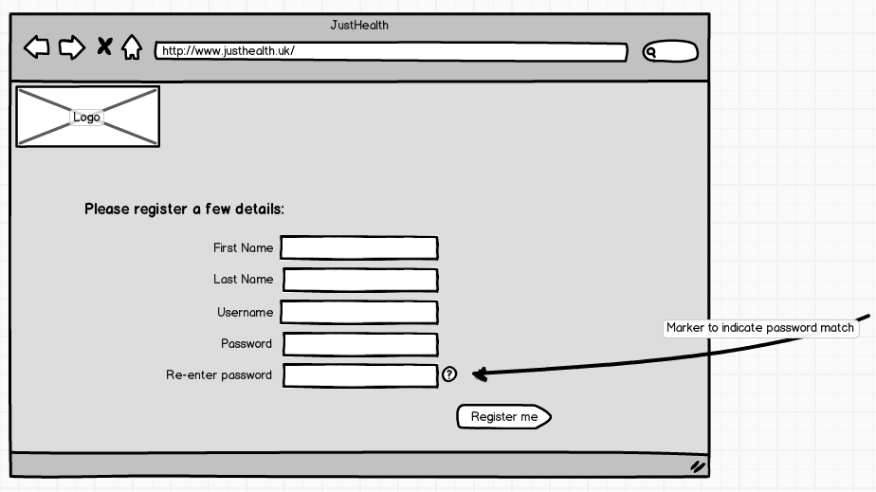

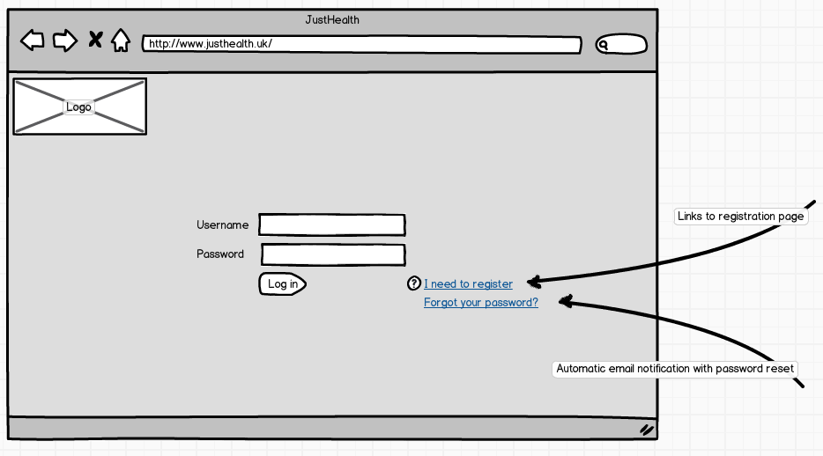

# 4.0 Usecase:

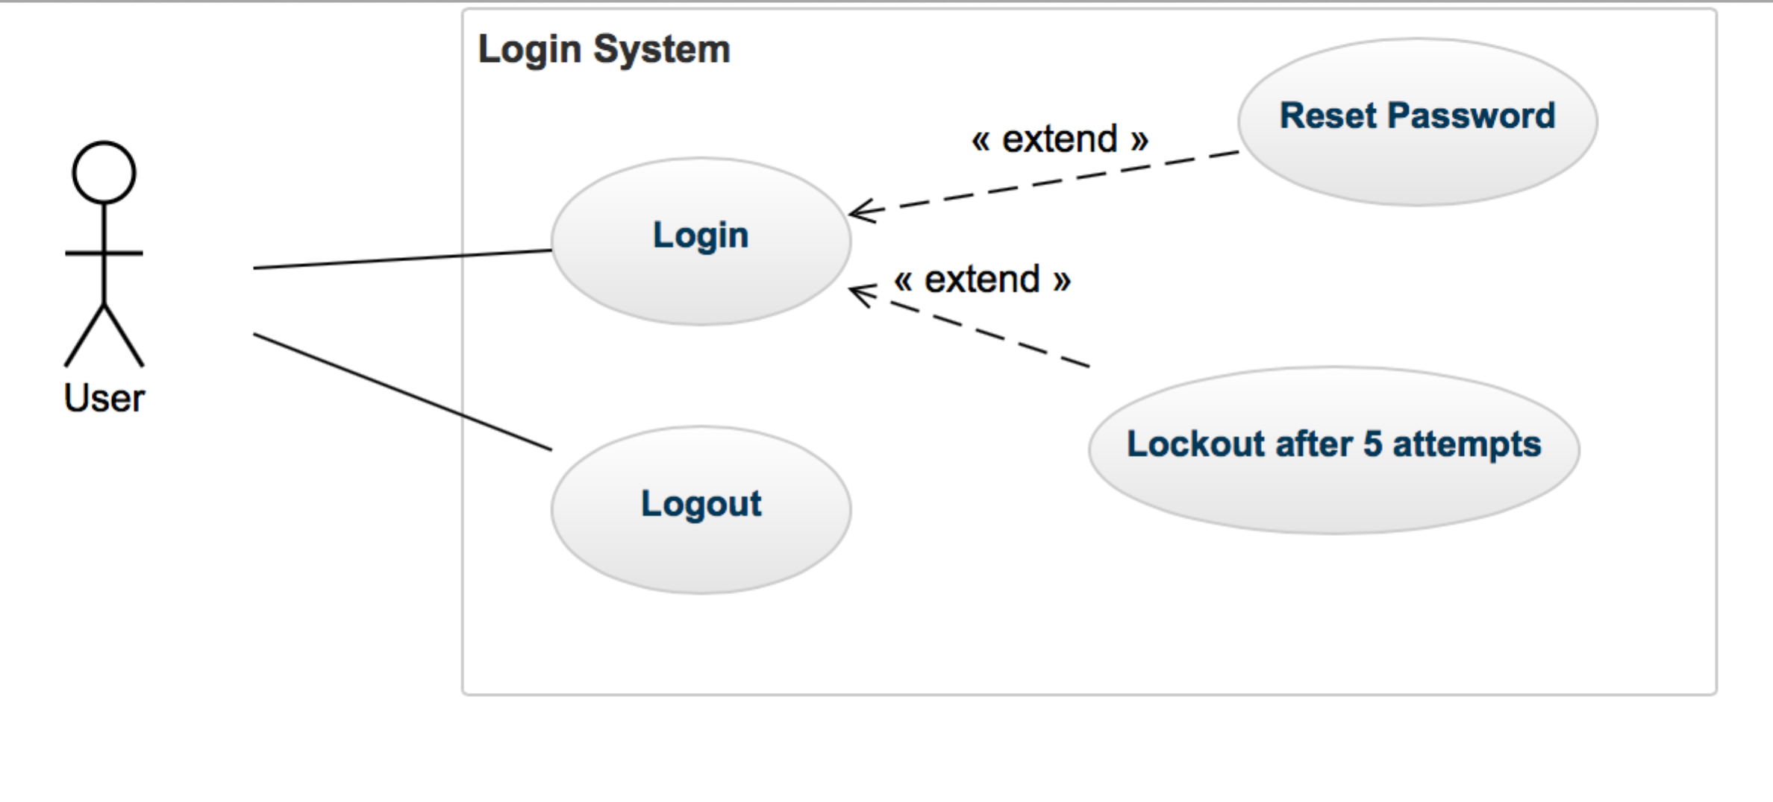

# 5.0 Database design:

## 5.1 Assumptions:

* One patient can have many types of medication
* A patient can have no types of medication
* A patient may not have carer
* A patient may have more than one carer
* A patient may not have a relative
* A patient can have more then one relative
* One user can have many passwords
* A password only belongs to one user
* A patient may not have any medical professionals
* A patient can have more then one medical professional

## 5.2 Conceptual Data Model

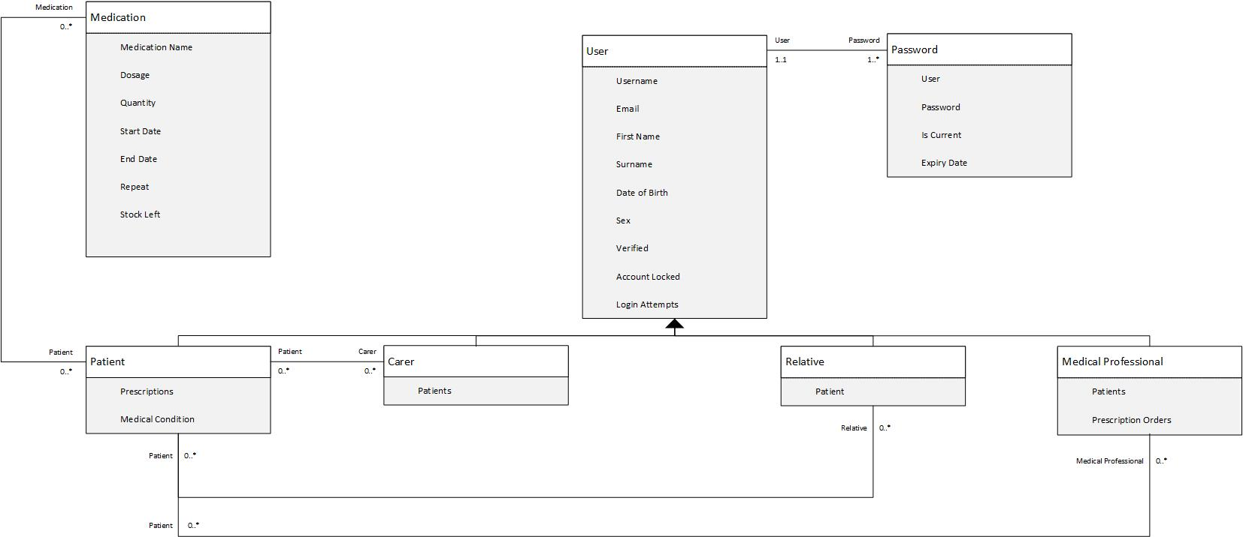

## C:\Users\Stephen\Documents\University\Final Year\CO600 - Final Year Project\JustHealth\Iteration 1\Database\Design\Logical.png5.3 Logical Data Model

Those tables that are highlighted in green are the tables that will be implemented in this iteration.